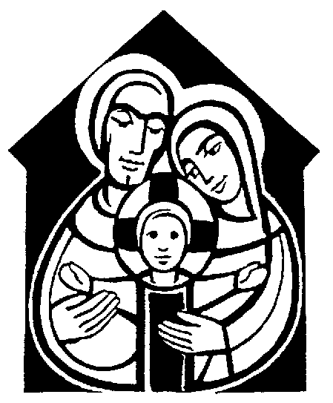Pew sheet 1-8; annotated order 9-16; individual stories follow

**ST ANDREW, ORFORD WITH LONGFORD**

**Crib Service 2019**

Christmas Eve

**First carol**: Once in Royal David's city

stood a lowly cattle shed,

where a mother laid her baby

in a manger for his bed:

Mary was that mother mild,

Jesus Christ her little child.

He came down to earth from heaven

who is God and Lord of all,

and his shelter was a stable,

and his cradle was a stall;

With the poor and mean and lowly

lived on earth our Saviour holy.

And our eyes at last shall see him

through his own redeeming love,

for that child so dear and gentle

is our Lord in heaven above;

and he leads his children on

to the place where he is gone.

Not in that poor lowly stable,

with the oxen standing by,

we shall see him; but in heaven,

set at God's right hand on high;

where like stars his children crowned

all in white shall wait around.

Opening words and welcome

**Countdown to Christmas – lighting the Advent candle stand**

**MC900326488[1]**

**Prayer**

**“The Donkey’s Story”**

## The donkey, Mary and Joseph are placed in the Stable

**Carol:** Little Donkey, little donkey, on the dusty road;

Got to keep on plodding onwards, with your precious load.

Been a long time, little donkey, thro’ the winter’s night.

Don’t give up now, little donkey, Bethlehem’s in sight.

Ring out the bells tonight, Bethlehem, Bethlehem;

Follow that star tonight ,Bethlehem, Bethlehem,

Little donkey, little donkey, had a heavy day,

Little donkey, carry Mary, safely on her way

Little donkey, little donkey, journey’s end is near.

There are wise men waiting for a sign to bring them here.

Do not falter, little donkey, there’s a star ahead.

It will guide you, little donkey, to a cattle shed.

Ring out the bells tonight, Bethlehem, Bethlehem;

Follow that star tonight, Bethlehem, Bethlehem,

Little donkey, little donkey, had a heavy day,

Little donkey, carry Mary, safely on her way

Little donkey, carry Mary, safely on her way.

Little donkey, carry Mary, safely on her way

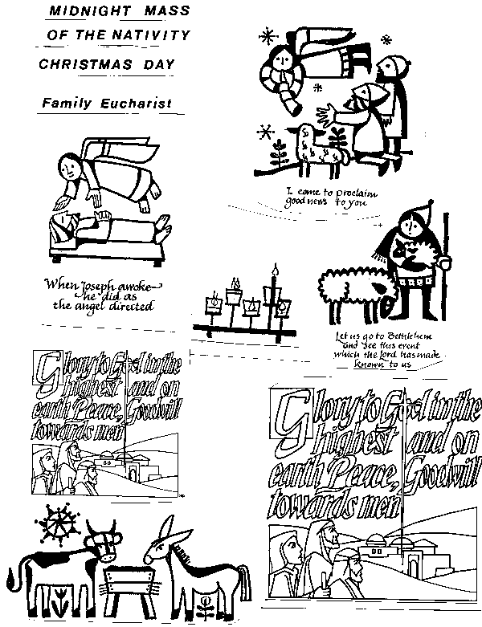**“The Ox’s Story”**

## An ox is placed in the Stable

**Carol:** Silent night, holy night,

All is calm, all is bright;

Round yon virgin Mother and Child

Holy infant, so tender and mild,

Sleep in heavenly peace,

Sleep in heavenly peace.

Silent night, holy night.

Shepherds quake at the sight,

glories stream from heaven afar,

heavenly hosts sing alleluia;

Christ the Saviour is born,

Christ the Saviour is born.

Silent night, holy night,

Son of God, love's pure light;

Radiance beams from thy holy face,

With the dawn of redeeming grace,

Jesus Lord at thy birth,

Jesus Lord at thy birth.

**“The Sheep’s Tale”**

## Baby Jesus is placed in the Stable, followed by the shepherds.

**Carol:** While shepherds watched their flocks by night,

all seated on the ground,

MC900155076[1]the angel of the Lord came down,

and glory shone around.

‘Fear not’ said he (for mighty dread

had seized their troubled mind);

‘glad tidings of great joy I bring

to you and all mankind.

‘To you in David’s town this day

is born of David’s line

a Saviour, who is Christ the Lord;

and this shall be the sign:

‘the heavenly babe you there shall find

to human view displayed,

all meanly wrapped in swathing bands,

and in a manger laid.’

Thus spake the seraph, and forthwith

appeared a shining throng

of angels praising God, who thus

addressed their joyful song:

‘All glory be to God on high,

and to the earth be peace:

good will henceforth from heaven to men

begin and never cease.’

MC900013236[1]**“The Camel’s Story”**

## The wise men are placed in the Stable

**Carol:** We three kings of orient are;

Bearing gifts we traverse afar

Field and fountain, moor and mountain,

Following yonder star:

O star of wonder, star of night,

Star with royal beauty bright,

Westward leading, still proceeding,

Guide us to thy perfect light.

Born a king on Bethlehem plain,

Gold I bring to crown him again

King for ever, ceasing never,

Over us all to reign:

O star of wonder ...

Frankincense to offer have I;

Incense owns a deity nigh:

Prayer and praising, all men raising,

Worship him, God most high:

O star of wonder ...

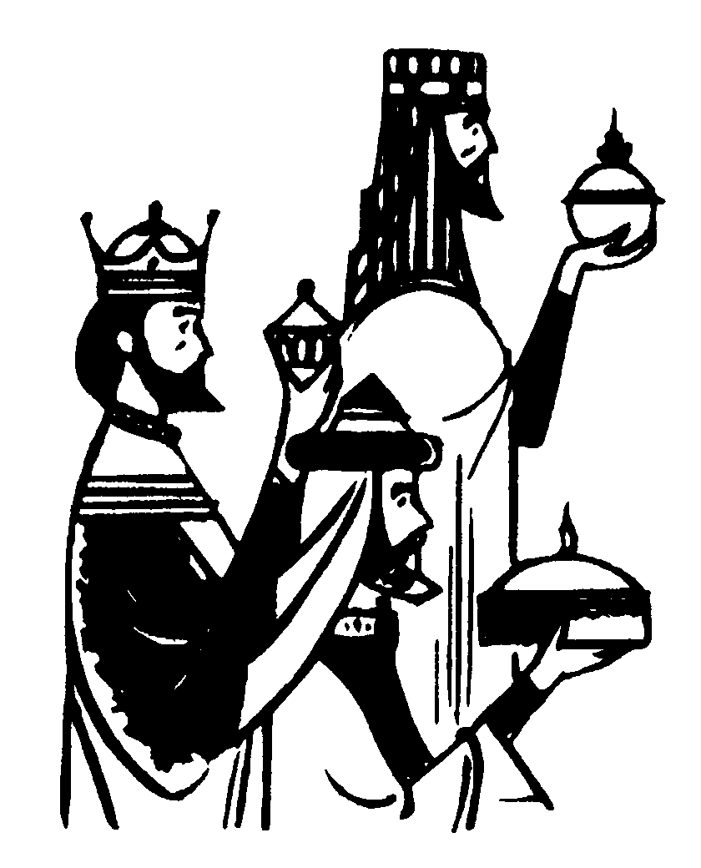

Myrrh is mine; its bitter perfume

Breathes a life of gathering gloom;

Sorrowing, sighing, bleeding, dying,

Sealed in the stone-cold tomb:

O star of wonder ...

Glorious now, behold him arise,

King, and God, and sacrifice!

Heav'n sings alleluia

Alleluia the earth replies:

O star of wonder, star of night,

Star with royal beauty bright,

Westward leading, still proceeding,

Guide us to thy perfect light.

**“Our Story”**

## The Church Mice are placed in the Stable

**Carol:** Away in a manger, no crib for a bed,

The little Lord Jesus laid down his sweet head,

The stars in the bright sky looked down where he lay,

The little Lord Jesus asleep on the hay.

The cattle are lowing, the baby awakes,

But little Lord Jesus no crying he makes;

I love thee Lord Jesus look down from the sky,

And stay by my side until morning is nigh.

Be near me Lord Jesus, I ask Thee to stay,

Close by me for ever and love me I pray,

Bless all the dear children in thy tender care,

And fit us for heaven to live with thee there.

**The Prayers, Lord’s Prayer and Blessing**

**Carol:** *Come and join the celebration’ it’s a very special day;*

*come and share our jubilation, there’s a new King born today!*

See the shepherds hurry down to Bethlehem;

gaze in wonder at the Son of God who lay before them.

‘God is with us’, round the world the message sing;

he is with us, ‘Welcome!’ all the bells on earth are pealing.

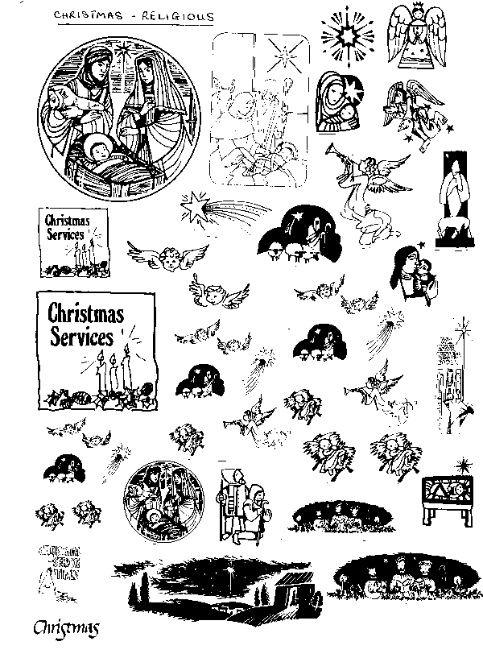

**\*\* Christmas Services \*\***

Tonight: 11.30pm Midnight Mass

Christmas Day: 10.00am Sung Family Eucharist (Communion)

with Carols

Our regular Sunday Service starts at 10 o’clock and lasts about an hour. Everyone is welcome to the service.

**ST ANDREW, ORFORD WITH LONGFORD**

**Crib Service 2019**

Christmas Eve

**First carol**: Once in Royal David's city

stood a lowly cattle shed,

where a mother laid her baby

in a manger for his bed:

Mary was that mother mild,

Jesus Christ her little child.

He came down to earth from heaven

who is God and Lord of all,

and his shelter was a stable,

and his cradle was a stall;

With the poor and mean and lowly

lived on earth our Saviour holy.

And our eyes at last shall see him

through his own redeeming love,

for that child so dear and gentle

is our Lord in heaven above;

and he leads his children on

to the place where he is gone.

Not in that poor lowly stable,

with the oxen standing by,

we shall see him; but in heaven,

set at God's right hand on high;

where like stars his children crowned

all in white shall wait around.

Opening words and welcome

**Countdown to Christmas – lighting the Advent candle stand**

**Countdown**

A few weeks ago, I went into Asda and there was a Christmas tree in the entrance. Near the bottom of the tree was a clock with large red numbers, counting how many big sleeps to Christmas. I think there were 32 sleeps before Christmas. I went again this morning and I wonder if you know how many big sleeps are on the clock now? … That’s right – just ONE.

In Church, we’ve been counting to Christmas, too, with our special Advent Candle stand. For the last four weeks, every Sunday, we’ve lit an extra candle. We started with just one, but yesterday we lit all four – and tonight, we’re going to light the special white one – the Christmas candle to remind us that Jesus, the Light of the World is born on Christmas Day.

***Light the candles***

***Prayer:*** Lord Jesus, Light of light,

You have come among us.

Help us who live by your light

to shine as lights in your world.

Glory to God in the highest.

Amen.

**MC900326488[1] “The Donkey’s Story”**

Life’s hard being a donkey. Up as the sun rises and you don’t get any rest. People expect you to carry all sorts of things on your back – heavy things, big things. And they’re so rough. They just throw them on and off you go! And hurry? There’s never a moment to stop. They keep on rushing me. Faster, faster is all they ever say. They never think to say thank you. I’m just a lowly beast of burden, there to carry anything they don’t want to carry.

So the other day was very strange. This chap Joseph came and hired me for a couple of days. Here we go again, I thought. What will it be this time. Mind you, he looked a kind, gentle man, but you can never tell. I heard him say he’d got to go over to Bethlehem – something about registering in the town where he’d been born. My owner said he was lucky – I was the last one in the stable – the others had already been hired and that was that. This Joseph chap said he had to take his wife, and she was having a baby so couldn’t walk all that way. That was my job – to carry her.

When we got to their house, you should have seen the luggage they had got together. Mary – that was her name – must have been getting things together for weeks. Looking at her, she must have been due to have the baby at any moment; no wonder she had so much to carry. I think she must have thought the baby would be born while they were travelling.

Anyway, they loaded me up and we set off. The roads were very busy, especially when we got near to Bethlehem. It was as though everyone in the world was going there. It had been a long day and it would soon be dark. We only just made it.

But you know the strangest thing of all. Even though I’d carried Mary and all that luggage, it wasn’t like carrying my normal load. They felt much lighter than anything I’d carried before. When we got to Bethlehem, I wasn’t really tired – more excited, though I couldn’t think why. It just seemed as though this was something very special.

And when they tied me up before going to look for somewhere to stay, Mary said Thank You – Thank you to a donkey! Would you believe it? I think it was the first time anyone had thanked me.

## The donkey, Mary and Joseph are placed in the Stable

**Carol:** Little Donkey, little donkey, on the dusty road;

Got to keep on plodding onwards, with your precious load.

Been a long time, little donkey, thro’ the winter’s night.

Don’t give up now, little donkey, Bethlehem’s in sight.

*Ring out the bells tonight, Bethlehem, Bethlehem;*

*Follow that star tonight ,Bethlehem, Bethlehem,*

*Little donkey, little donkey, had a heavy day,*

*Little donkey, carry Mary, safely on her way*

Little donkey, little donkey, journey’s end is near.

There are wise men waiting for a sign to bring them here.

Do not falter, little donkey, there’s a star ahead.

It will guide you, little donkey, to a cattle shed.

*Ring out the bells tonight, Bethlehem, Bethlehem;*

*Follow that star tonight, Bethlehem, Bethlehem,*

*Little donkey, little donkey, had a heavy day,*

*Little donkey, carry Mary, safely on her way*

*Little donkey, carry Mary, safely on her way.*

*Little donkey, carry Mary, safely on her way*



**“The Ox’s Story”**

I work hard during the day, and when I’ve finished pulling that great plough, I’m ready for something to eat and a good night’s sleep. As I came home, I noticed Bethlehem was very busy – much busier than normal. Someone said it was the Governor’s fault.

Anyway, I got into the stable, had something to eat from the freshly filled manger, and found a draught free corner. You wouldn’t believe how cold it gets at night once the sun’s gone down.

The inn next door was busy. I could hear loud voices, and I could hear the innkeeper telling someone all his rooms were full. The bloke who was asking said he was desperate for somewhere to sleep because his wife needed a bed. Couldn’t he squeeze them in somewhere – anywhere?

In the end, the innkeeper gave in. He told them that he had a stable round the back and they could sleep in there if they wanted. You’d have thought he was offering them a palace, they were so grateful. He brought them round and in the dim glow of his lamp, I saw them. Joseph, that was what the older man was called, and his wife, a young lass called Mary. He helped them spread out some extra straw and they made her comfortable. The innkeeper left his lamp and went back to his other customers.

After all the hustle and bustle of the day, the pushing and shoving on the street and the noise in the inn, a sudden peace descended on the stable. Nothing else mattered. This was the place to be. It felt warmer, too, though I can’t say why. I don’t think I’ve ever felt so comfortable and happy.

And then, just a few hours later, Mary gave birth to a tiny baby. It was a little boy. Mary wrapped him in some clothes she’d brought with her while Joseph made a bed for him in the manger. He used the finest hay – not that I minded. In fact, I was glad to be able to let him use my manger. It seemed just right for him. And just before Mary put him in the manger, she kissed him. Even though I was big and strong, I felt a tear come to my eye.

## An ox is placed in the Stable

**Carol:** Silent night, holy night,

All is calm, all is bright;

Round yon virgin Mother and Child

Holy infant, so tender and mild,

Sleep in heavenly peace,

Sleep in heavenly peace.

Silent night, holy night.

Shepherds quake at the sight,

glories stream from heaven afar,

heavenly hosts sing alleluia;

Christ the Saviour is born,

Christ the Saviour is born.

Silent night, holy night,

Son of God, love's pure light;

Radiance beams from thy holy face,

With the dawn of redeeming grace,

Jesus Lord at thy birth,

MC900155076[1]Jesus Lord at thy birth.

**“The Sheep’s Tale!”**

People think we sheep are silly. All we do, they say, is eat grass and follow one another round, but it’s not true. We’re really quite bright.

The other night, the shepherds had rounded us all up and put us into the fold. They’d lit a big fire by the door to keep us safe. Well, that’s what they said, but judging by the way they all sat round it and kept rubbing their hands together, I think it was lit because they were cold and wanted to warm themselves.

They’re quite a rough bunch, these shepherds. Always laughing and joking and making fun of one another. By now, it was very dark – only the light from the fire and a clear sky, full of stars. They were getting tired and one or two had already fallen asleep.

Suddenly the sky was filled with light. It was so bright that it was more like day and the light filled the sky. What’s more, an angel appeared out of nowhere. I didn’t know what it was at first, but when the shepherds talked about it later, they said it must have been an angel – it couldn’t possibly be anything else.

No sooner had the angel appeared than the shepherds fell silent. It’s not like them – they’re never short of words normally. And even in the firelight, you could see they were frightened. They went ever so pale. I think the angel saw it too, because the first thing he told them was not to be afraid.

And then he went on to tell them about something quite amazing that had happened that night in Bethlehem. We weren’t far from Bethlehem – you could see it from our hill. They said God’s son had been born there that very night. Can you imagine it – in Bethlehem of all places! Then the angel was joined by lots of other angels and they all began to sing. I’ve never heard such beautiful singing. They were praising God. And then they went. The night darkened.

One of the young shepherds said to the others “What are waiting for? Come on, let’s go and see for ourselves.”. The others agreed. They picked me up because I was only little and then closed the door to the fold to keep the others safe. And off we went. I’ve never seen them run like they did that night. They couldn’t get there quickly enough.

When we got into town, we went to a stable behind the inn and found a young family – a man and woman, and a tiny, newborn baby. The parents said the baby’s name was Jesus. The shepherds talked to the parents, but I just stood and looked. And little baby Jesus turned to me and gave me a big smile. I’ll never forget it – and I don’t think he ever forgot me, either.

## Baby Jesus is placed in the Stable, followed by the shepherds.

MC900155076[1] **Carol:** While shepherds watched their flocks by night,

all seated on the ground,

the angel of the Lord came down,

and glory shone around.

‘Fear not’ said he (for mighty dread

had seized their troubled mind);

‘glad tidings of great joy I bring

to you and all mankind.

‘To you in David’s town this day

is born of David’s line

a Saviour, who is Christ the Lord;

and this shall be the sign:

‘the heavenly babe you there shall find

to human view displayed,

all meanly wrapped in swathing bands,

and in a manger laid.’

Thus spake the seraph, and forthwith

appeared a shining throng

of angels praising God, who thus

addressed their joyful song:

‘All glory be to God on high,

and to the earth be peace:

good will henceforth from heaven to men

begin and never cease.’

**MC900013236[1]“The Camel’s Story”**

I live in a great palace and my master is a very clever man. He reads a lot during the day, but once it has gone dark, he’s out in the courtyard looking at the stars. He’s always done it – and he usually goes inside when he’s finished and draws lots of star maps.

The other night, he came out as usual, and stood there, gazing up at the sky as he always does. I like watching him – it passes the time. But this particular night, he suddenly started to scratch his head. He went inside and brought out the map he’d done the previous day. He scratched his head again. I realised that there was something odd going on, but I didn’t know what at the time.

In a moment or two, there was a great commotion as he called out to his servants. First he pointed to a bright star in the sky and then he showed them the chart. It seems this bright star had only appeared that night – and it could mean only one thing. A Baby had been born – not any ordinary baby, but a very special one that had been foretold long ago.

The servants started rushing round, getting things together. They came to me and started to put my saddle on – at night! You’re going on an important journey, they told me, and we’ve got to start straight away.

After we’d been travelling some weeks, we met up with another camel train and they were following the star, just as we were. We walked together, and met a third camel train , also following the star. I don’t know how they all knew, but they did, and we went together. It seemed as though we’d never get there, but eventually we got to a place called Jerusalem and stopped to ask directions. My master went in to Herod’s palace. When he came out, he looked very puzzled. We have to go to Bethlehem he said, and the king told us to come back and tell him when we had found the baby. But, may master said, I don’t trust Herod.

Eventually, we came to a very tiny house and because the star had stopped, the three wise men decided to look inside. They came back and picked up gifts for the baby – gifts we brought all the way from the East. There was gold, frankincense and myrrh and they gave them to the child.

When they had finished, they said it was time to go home, but we didn’t go back by Jerusalem. No, we went a very different way home!

## The wise men are placed in the Stable

**Carol:** We three kings of orient are;

Bearing gifts we traverse afar

Field and fountain, moor and mountain,

Following yonder star:

*O star of wonder, star of night,*

*Star with royal beauty bright,*

*Westward leading, still proceeding,*

*Guide us to thy perfect light.*

Born a king on Bethlehem plain,

Gold I bring to crown him again

King for ever, ceasing never,

Over us all to reign:

O star of wonder ...

Frankincense to offer have I;

Incense owns a deity nigh:

Prayer and praising, all men raising,

Worship him, God most high:

O star of wonder...

Myrrh is mine; its bitter perfume

Breathes a life of gathering gloom;

Sorrowing, sighing, bleeding, dying,

Sealed in the stone-cold tomb:

O star of wonder ...

Glorious now, behold him arise,

King, and God, and sacrifice!

Heav'n sings alleluia

Alleluia the earth replies:

O star of wonder ...

**“Our Story”**

Tonight, it’s not just the donkey, the ox, the sheep and the camel who have come to the stable – we’re here too. We’re here to see the baby born in the stable, just as the animals and the people who came with them went to see the baby Jesus.

One of my favourite carols, which begins *In the bleak mid-winter*, reminds us that what Jesus wants more than gifts is our love. We give gifts to one another, but we offer Jesus our love – just as Mary kissed the baby Jesus after he was born. Tonight, we remember his birth in the stable, and tonight we offer him our love and our thanks.

## The Church Mice are placed in the Stable

**Carol:** Away in a manger, no crib for a bed,

The little Lord Jesus laid down his sweet head,

The stars in the bright sky looked down where he lay,

The little Lord Jesus asleep on the hay.

The cattle are lowing, the baby awakes,

But little Lord Jesus no crying he makes;

I love thee Lord Jesus look down from the sky,

And stay by my side until morning is nigh.

Be near me Lord Jesus, I ask Thee to stay,

Close by me for ever and love me I pray,

Bless all the dear children in thy tender care,

And fit us for heaven to live with thee there.

**The Prayers,**

Lord Jesus, you were born in a stable and grew up with Mary and Joseph. We thank you for coming into our world and ask you to bless our families, tonight and for ever more. **Amen**

We pray for all children in our world, and especially those who are unhappy or sad tonight. Fill them with joy and peace this Christmas and always. **Amen**

**Lord’s Prayer and Blessing**

May the Lord Jesus who was born this night in Bethlehem fill you with his love and give you joy and peace, and the blessing of God almighty, the Father, the Son and the Holy Spirit, be with you and remain with you always. **Amen**

**Carol:** *Come and join the celebration’ it’s a very special day;*

*come and share our jubilation, there’s a new King born today!*

See the shepherds hurry down to Bethlehem;

gaze in wonder at the Son of God who lay before them.

‘God is with us’, round the world the message sing;

he is with us, ‘Welcome!’ all the bells on earth are pealing.

**\*\* Christmas Services \*\***

Tonight: 11.30pm Midnight Mass

Christmas Day: 10.00am Sung Family Eucharist (Communion)

Our regular Sunday Service starts at 10 o’clock, lasts about an hour and includes Sunday School during the service (except in holiday time). Everyone is welcome to the service and the Sunday School is open to children from about three years old and upwards.

**Countdown**

When we start our worhship in school, we usually light three candles. For the last few eeks, though, there has also been a special Advent candle and an Advent ring, like the one we have here.

The advent candle had a number one at the top and it went down to twenty-four. Each day, we let it burn a little more, so that there’s only one mark left – it shows we’re nearly at Christmas. I don’t know about you, but each time I see the candle a bit shorter, I get a bit more excited.

We started Advent in church by lighting just onre candle but today, we lit all four – and tonight, we’re going to light the special white one – the Christ candle to remind us that Jesus, the Light of the World is born on Christmas Day.

***Light the candles***

***Prayer:*** Lord Jesus, Light of light,

You have come among us.

Help us who live by your light

to shine as lights in your world.

Glory to God in the highest.

Amen.

**The Donkey’s story:**

Life’s hard being a donkey. Up as the sun rises and you don’t get any rest. People expect you to carry all sorts of things on your back – heavy things, big things. And they’re so rough. They just throw them on and off you go! And hurry? There’s never a moment to stop. They keep on rushing me. Faster, faster is all they ever say. They never think to say thank you. I’m just a lowly beast of burden, there to carry anything they don’t want to carry.

So the other day was very strange. This chap Joseph came and hired me for a couple of days. Here we go again, I thought. What will it be this time. Mind you, he looked a kind, gentle man, but you can never tell. I heard him say he’d got to go over to Bethlehem – something about registering in the town where he’d been born. My owner said he was lucky – I was the last one in the stable – the others had already been hired and that was that. This Joseph chap said he had to take his wife, and she was having a baby so couldn’t walk all that way. That was my job – to carry her.

When we got to their house, you should have seen the luggage they had got together. Mary – that was her name – must have been getting things together for weeks. Looking at her, she must have been due to have the baby at any moment; no wonder she had so much to carry. I think she must have thought the baby would be born while they were travelling.

Anyway, they loaded me up and we set off. The roads were very busy, especially when we got near to Bethlehem. It was as though everyone in the world was going there. It had been a long day and it would soon be dark. We only just made it.

But you know the strangest thing of all. Even though I’d carried Mary and all that luggage, it wasn’t like carrying my normal load. They felt much lighter than anything I’d carried before. When we got to Bethlehem, I wasn’t really tired – more excited, though I couldn’t think why. It just seemed as though this was something very special.

And when they tied me up before going to look for somewhere to stay, Mary said Thank You – Thank you to a donkey! Would you believe it? I think it was the first time anyone had thanked me.

**The Ox’s story:**

I work hard during the day, and when I’ve finished pulling that great plough, I’m ready for something to eat and a good night’s sleep. As I came home, I noticed Bethlehem was very busy – much busier than normal. Someone said it was the Governor’s fault.

Anyway, I got into the stable, had something to eat from the freshly filled manger, and found a draught free corner. You wouldn’t believe how cold it gets at night once the sun’s gone down.

The inn next door was busy. I could hear loud voices, and I could hear the innkeeper telling someone all his rooms were full. The bloke who was asking said he was desperate for somewhere to sleep because his wife needed a bed. Couldn’t he squeeze them in somewhere – anywhere?

In the end, the innkeeper gave in. He told them that he had a stable round the back and they could sleep in there if they wanted. You’d have thought he was offering them a palace, they were so grateful. He brought them round and in the dim glow of his lamp, I saw them. Joseph, that was what the older man was called, and his wife, a young lass called Mary. He helped them spread out some extra straw and they made her comfortable. The innkeeper left his lamp and went back to his other customers.

After all the hustle and bustle of the day, the pushing and shoving on the street and the noise in the inn, a sudden peace descended on the stable. Nothing else mattered. This was the place to be. It felt warmer, too, though I can’t say why. I don’t think I’ve ever felt so comfortable and happy.

And then, just a few hours later, Mary gave birth to a tiny baby. It was a little boy. Mary wrapped him in some clothes she’d brought with her while Joseph made a bed for him in the manger. He used the finest hay – not that I minded. In fact, I was glad to be able to let him use my manger. It seemed just right for him. And just before Mary put him in the manger, she kissed him. Even though I was big and strong, I felt a tear come to my eye.

**The Sheep’s tale:**

People think we sheep are silly. All we do, they say, is eat grass and follow one another round., but it’s not true. We’re really quite bright.

The other night, the shepherds had rounded us all up and put us into the fold. They’d lit a big fire by the door to keep us safe. Well, that’s what they said, but judging by the way they all sat round it and kept rubbing their hands together, I think it was lit because they were cold and wanted to warm themselves.

They’re quite a rough bunch, these shepherds. Always laughing and joking and making fun of one another. By now, it was very dark – only the light from the fire and a clear sky, full of stars. They were getting tired and one or two had already fallen asleep.

Suddenly the sky was filled with light. It was so bright that it was more like day and the light filled the sky. What’s more, an angel appeared out of nowhere. I didn’t know what it was at first, but when the shepherds talked about it later, they said it must have been an angel – it couldn’t possibly be anything else.

No sooner had the angel appeared than the shepherds fell silent. It’s not like them – they’re never short of words normally. And even in the firelight, you could see they were frightened. They went ever so pale. I think the angel saw it too, because the first thing he told them was not to be afraid.

And then he went on to tell them about something quite amazing that had happened that night in Bethlehem. We weren’t far from Bethlehem – you could see it from our hill. They said God’s son had been born there that very night. Can you imagine it – in Bethlehem of all places! Then the angel was joined by lots of other angels and they all began to sing. I’ve never heard such beautiful singing. They were praising God. And then they went. The night darkened.

One of the young shepherds said to the others “What are waiting for? Come on, let’s go and see for ourselves.”. The others agreed. They picked me up because I was only little and then closed the door to the fold to keep the others safe. And off we went. I’ve never seen them run like they did that night. They couldn’t get there quickly enough.

When we got into town, we went to a stable behind the inn and found a young family – a man and woman, and a tiny, newborn baby. The parents said the baby’s name was Jesus. The shepherds talked to the parents, but I just stood and looked. And little baby Jesus turned to me and gave me a big smile. I’ll never forget it – and I don’t think he ever forgot me, either.

**The Camel’s story:**

I live in a great palace and my master is a very clever man. He reads a lot during the day, but once it has gone dark, he’s out in the courtyard looking at the stars. He’s always done it – and he usually goes inside when he’s finished and draws lots of star maps.

The other night, he came out as usual, and stood there, gazing up at the sky as he always does. I like watching him – it passes the time. But this particular night, he suddenly started to scratch his head. He went inside and brought out the map he’d done the previous day. He scratched his head again. I realised that there was something odd going on, but I didn’t know what at the time.

In a moment or two, there was a great commotion as he called out to his servants. First he pointed to a bright star in the sky and then he showed them the chart. It seems this bright star had only appeared that night – and it could mean only one thing. A Baby had been born – not any ordinary baby, but a very special one that had been foretold long ago.

The servants started rushing round, getting things together. They came to me and started to put my saddle on – at night! You’re going on an important journey, they told me, and we’ve got to start straight away.

After we’d been travelling some weeks, we met up with another camel train and they were following the star, just as we were. We walked together, and met a third camel train , also following the star. I don’t know how they all knew, but they did, and we went together. It seemed as though we’d never get there, but eventually we got to a place called Jerusalem and stopped to ask directions. My master went in to Herod’s palace. When he came out, he looked very puzzled. We have to go to Bethlehem he said, and the king told us to come back and tell him when we had found the baby. But, my master said, “I don’t trust Herod”.

Eventually, we came to a very tiny house and because the star had stopped, the three wise men decided to look inside. They came back and picked up gifts for the baby – gifts we brought all the way from the East. There was gold, frankincense and myrrh and they gave them to the child.

When they had finished, they said it was time to go home, but we didn’t go back by Jerusalem. No, we went a very different way home!**Our story:**

Tonight, it’s not just the donkey, the ox, the sheep and the camel who have come to the stable – we’re here too. We’re here to see the baby born in the stable, just as the animals and the people who came with them went to see the baby Jesus.

One of my favourite carols, which we’re going to sing in a minute, reminds us that what Jesus wants more than gifts is our love. We give gifts to one another, but we offer Jesus our love – just as Mary kissed the baby Jesus after he was born. Tonight, we remember his birth in the stable, and tonight we offer him our love and our thanks.

Notes for 2019:

Attendance: approx 26 adults and 10 children

This lasted about 45 minutes – took 5 minutes to ask people to bring up the figures.

Only just enough children for figures so didn’t use the mice this year.